FREEDOM
Christian Life after High School

Introductions

Divide into small groups. You have five minutes to complete this sentence in as many ways as possible: Since I have graduated from high school I am now free to…

Spiritual Freedom
John 8:34
Jesus replied, “I tell you the truth, everyone who sins is a slave to sin.”

What does a slave do?

How are all people like slaves in regard to sin?

John 8:36
“So if the Son sets you free, you will be free indeed.”

How has Jesus set us free from sin?

A believer has the freedom to say ________ to God and ______ to sin.

You and your non-Christian friend are both invited to a party where you know there will be drugs, underage drinking as well as other illegal and/or immoral activities. Why would a Christian decide to skip that party? Why would an unbeliever decide to skip that party? What is the difference since both seemingly said no to sin?

1 Corinthians 15:56-57
The sting of death is sin, and the power of sin is the law. But thanks be to God! He gives us the victory through our Lord Jesus Christ.

Hebrews 2:14
Since the children have flesh and blood, he too shared in their humanity so that by his death he might destroy him who holds the power of death—that is, the devil.

From what else has Jesus set us free?

Galatians 5:13
You, my brothers, were called to be free. But do not use your freedom to indulge the sinful nature; rather, serve one another in love.

Some people may see the freedom we have in Christ as a get out of jail free card. They think that since Christ has forgiven us we can do anything we want and still be okay with God. Why is this attitude not true freedom?

Galatians 5:16-18
So I say, live by the Spirit, and you will not gratify the desires of the sinful nature. ¹⁷ For the sinful nature desires what is contrary to the Spirit, and the Spirit what is contrary to the sinful nature. They are in conflict with each other, so that you do not do what you want. ¹⁸ But if you are led by the Spirit, you are not under law.

When the Holy Spirit gave you faith a great battle began within you. That sinful human nature had been unopposed but now a new nature was created. This new nature wants to follow the Lord out of love for his forgiveness. How can we be sure we are being led by the Spirit and how do we win the conflict against our sinful nature?

Challenges to Faith
Get into small groups and put together a list of things, events, or people that might challenge the faith of a recent high school graduate.

2 Peter 3:3-5
First of all, you must understand that in the last days scoffers will come, scoffing and following their own evil desires. They will say, “Where is this ‘coming’ he promised? Ever since our fathers died, everything goes on as it has since the beginning of creation.” But they deliberately forget that long ago by God’s word the heavens existed and the earth was formed out of water and by water.

What do these scoffers not believe? Who might you run into (if you haven’t already) that could be a “scoffer”?

What “proof” will they use to convince you that the Bible is not a good source of truth?

2 Peter 3:18
But grow in the grace and knowledge of our Lord and Savior Jesus Christ.

What is Peter’s advice for us as we go into a world that can be hostile to faith in Christ?

Galatians 5:19-21
The acts of the sinful nature are obvious: sexual immorality, impurity and debauchery; ²⁰ idolatry and witchcraft; hatred, discord, jealousy, fits of rage, selfish ambition, dissensions, factions ²¹ and envy; drunkenness, orgies, and the like. I warn you, as I did before, that those who live like this will not inherit the kingdom of God.

Paul covers a lot of the temptations facing young adults in this list. What is Paul’s warning about sin? How can temptation and sin lead us away from our Lord?

Some of the common temptations for recent high school graduates are in this list too. Let’s go through some of them so we know what God says about each.

Genesis 2:24
For this reason a man will leave his father and mother and be united to his wife, and they will become one flesh.
In what context is sex good?

Therefore, when is it sin?

1 Thessalonians 4:3-5
It is God’s will that you should be sanctified: that you should avoid sexual immorality; that each of you should learn to control his own body in a way that is holy and honorable, not in passionate lust like the heathen, who do not know God.

God has made you his child through baptism. He has forgiven all your sins and given you a new nature that wants to follow God’s will. What are some things you can do to avoid sexual immorality?

“You cannot prevent the birds from flying over your head, but you can certainly keep them from building a nest in your hair.” – Martin Luther
What is Luther saying about temptations with these words?

Ephesians 5:3-4
But among you there must not be even a hint of sexual immorality, or of any kind of impurity, or of greed, because these are improper for God’s holy people. Nor should there be obscenity, foolish talk or coarse joking, which are out of place, but rather thanksgiving.

What excuses might a Christian make for doing the following and how does the above passage make it clear that these excuses are not valid?

Looking at pornography

Telling a coarse joke

Laughing at a coarse joke

Moving in with a boyfriend or girlfriend

1 John 1:8-9
If we claim to be without sin, we deceive ourselves and the truth is not in us. If we confess our sins, he is faithful and just and will forgive us our sins and purify us from all unrighteousness.
When we sin, what is our response as a child of God?

Get into small groups. Read the following four passages and answer the following questions: When is drinking alcohol a sin? What are spiritual and earthly consequences of drinking alcohol in a sinful manner?

Proverbs 20:1
Wine is a mocker and beer a brawler; whoever is led astray by them is not wise.

Ephesians 5:18
Do not get drunk on wine, which leads to debauchery. Instead, be filled with the Spirit.

Proverbs 23:31-35
Do not gaze at wine when it is red, when it sparkles in the cup, when it goes down smoothly! In the end it bites like a snake and poisons like a viper. Your eyes will see strange sights and your mind imagine confusing things. You will be like one sleeping on the high seas, lying on top of the rigging. “They hit me,” you will say, “but I’m not hurt! They beat me, but I don’t feel it! When will I wake up so I can find another drink?”

Romans 13:1-2
Everyone must submit himself to the governing authorities, for there is no authority except that which God has established. The authorities that exist have been established by God. Consequently, he who rebels against the authority is rebelling against what God has instituted, and those who do so will bring judgment on themselves.

Why is it sinful to use illegal drugs (street drugs or prescriptions that are not yours)?

1 Peter 5:8
Be self-controlled and alert. Your enemy the devil prowls around like a roaring lion looking for someone to devour.

How can using drugs or abusing alcohol affect your earthly life and plans? How can it affect your spiritual life?

Living the Christian Life

Galatians 5:22-24
But the fruit of the Spirit is love, joy, peace, patience, kindness, goodness, faithfulness, gentleness and self-control. Against such things there is no law. Those who belong to Christ Jesus have crucified the sinful nature with its passions and desires.
Moving out of your parent’s house, starting a new job, going to college – these can all be reasons people give for going a little wild in life. You are only young once so don’t waste it by following the rules is the thought. But you are different. You have been freed from the sin and are now free to let the fruit of the Spirit show in your life. Brainstorm with your group ways in which you may have the opportunity to let the fruit of the Sprit show in you life.

Following the Lord does not mean that you are supposed to put on a serious face in life and never have any fun. You are about to enter a time in your life when you have lots of freedom to do lots of things, fun things. What are you looking forward to doing?

Your online appearance is also part of living a Christian life. Who might be (or is) looking at what we put online and what we text? How can this affect your future?

Deuteronomy 5:16
Honor your father and your mother, as the Lord your God has commanded you, so that you may live long and that it may go well with you in the land the Lord your God is giving you.

Colossians 3:20
Children, obey your parents in everything, for this pleases the Lord.

What blessings does God give to those who obey their parents?

Why do we as Christians, obey our parents?

Proverbs 23:22
Listen to your father, who gave you life, and do not despise your mother when she is old.
When you were young, your parents decided what you were going to do. Clean your room. Do the dishes. Do your homework before video games. At some point you began to have some input into decisions. I want to play baseball instead of run track. I want to learn to play the trombone, not the trumpet. What does the Proverbs passage tell us about our relationship with our parents as we become adults and have families of our own?

Deuteronomy 5:16, above, is the Fourth Commandment. Have these young adults broken this commandment? Explain.
- Susan’s parents want her to become a doctor. They made her take all the right classes in high school and she is now in her freshman year taking pre-med classes at the university. Susan does not like her pre-med classes and does not want to be a doctor. She wants to be an elementary teacher and changes majors without telling her parents.
- Joseph graduates from college and is offered two jobs. One is 30 miles from his parent’s house. The other is across the country. His parents have made it clear that they want him close. He takes the job far away.
- William’s parents pay for him to go to the college of his choice. He rarely attends classes, does just enough to stay in school and parties with his friends almost every night.

Your relationship with your parents will change after high school. Some students and parents try to keep their relationship exactly the same. The parents become helicopter parents always on campus, always checking on you. Or the student becomes a clinger, always going home, always on the phone with mom or dad. On the other hand, some students completely cut off their parents after high school. They almost never come home on school breaks. They don’t call or text or email. What are the problems with each of these extremes?

Life Goals
People have different goals in life. What steps could someone take to reach the following goals?

Financial Success

Happy Life

Make a Difference

Discover Something New

Eternal Life

Which of these goals is most important?

Mark 4:18-19
Still others, like seed sown among thorns, hear the word; ¹⁹ but the worries of this life, the deceitfulness of wealth and the desires for other things come in and choke the word, making it unfruitful.
What keeps some people from having heaven as their goal in life?

Matthew 6:31-33
So do not worry, saying, ‘What shall we eat?’ or ‘What shall we drink?’ or ‘What shall we wear?’ ³² For the pagans run after all these things, and your heavenly Father knows that you need them. ³³ But seek first his kingdom and his righteousness, and all these things will be given to you as well.
What does Jesus tell us about how following him fits in with the rest of our earthly goals?

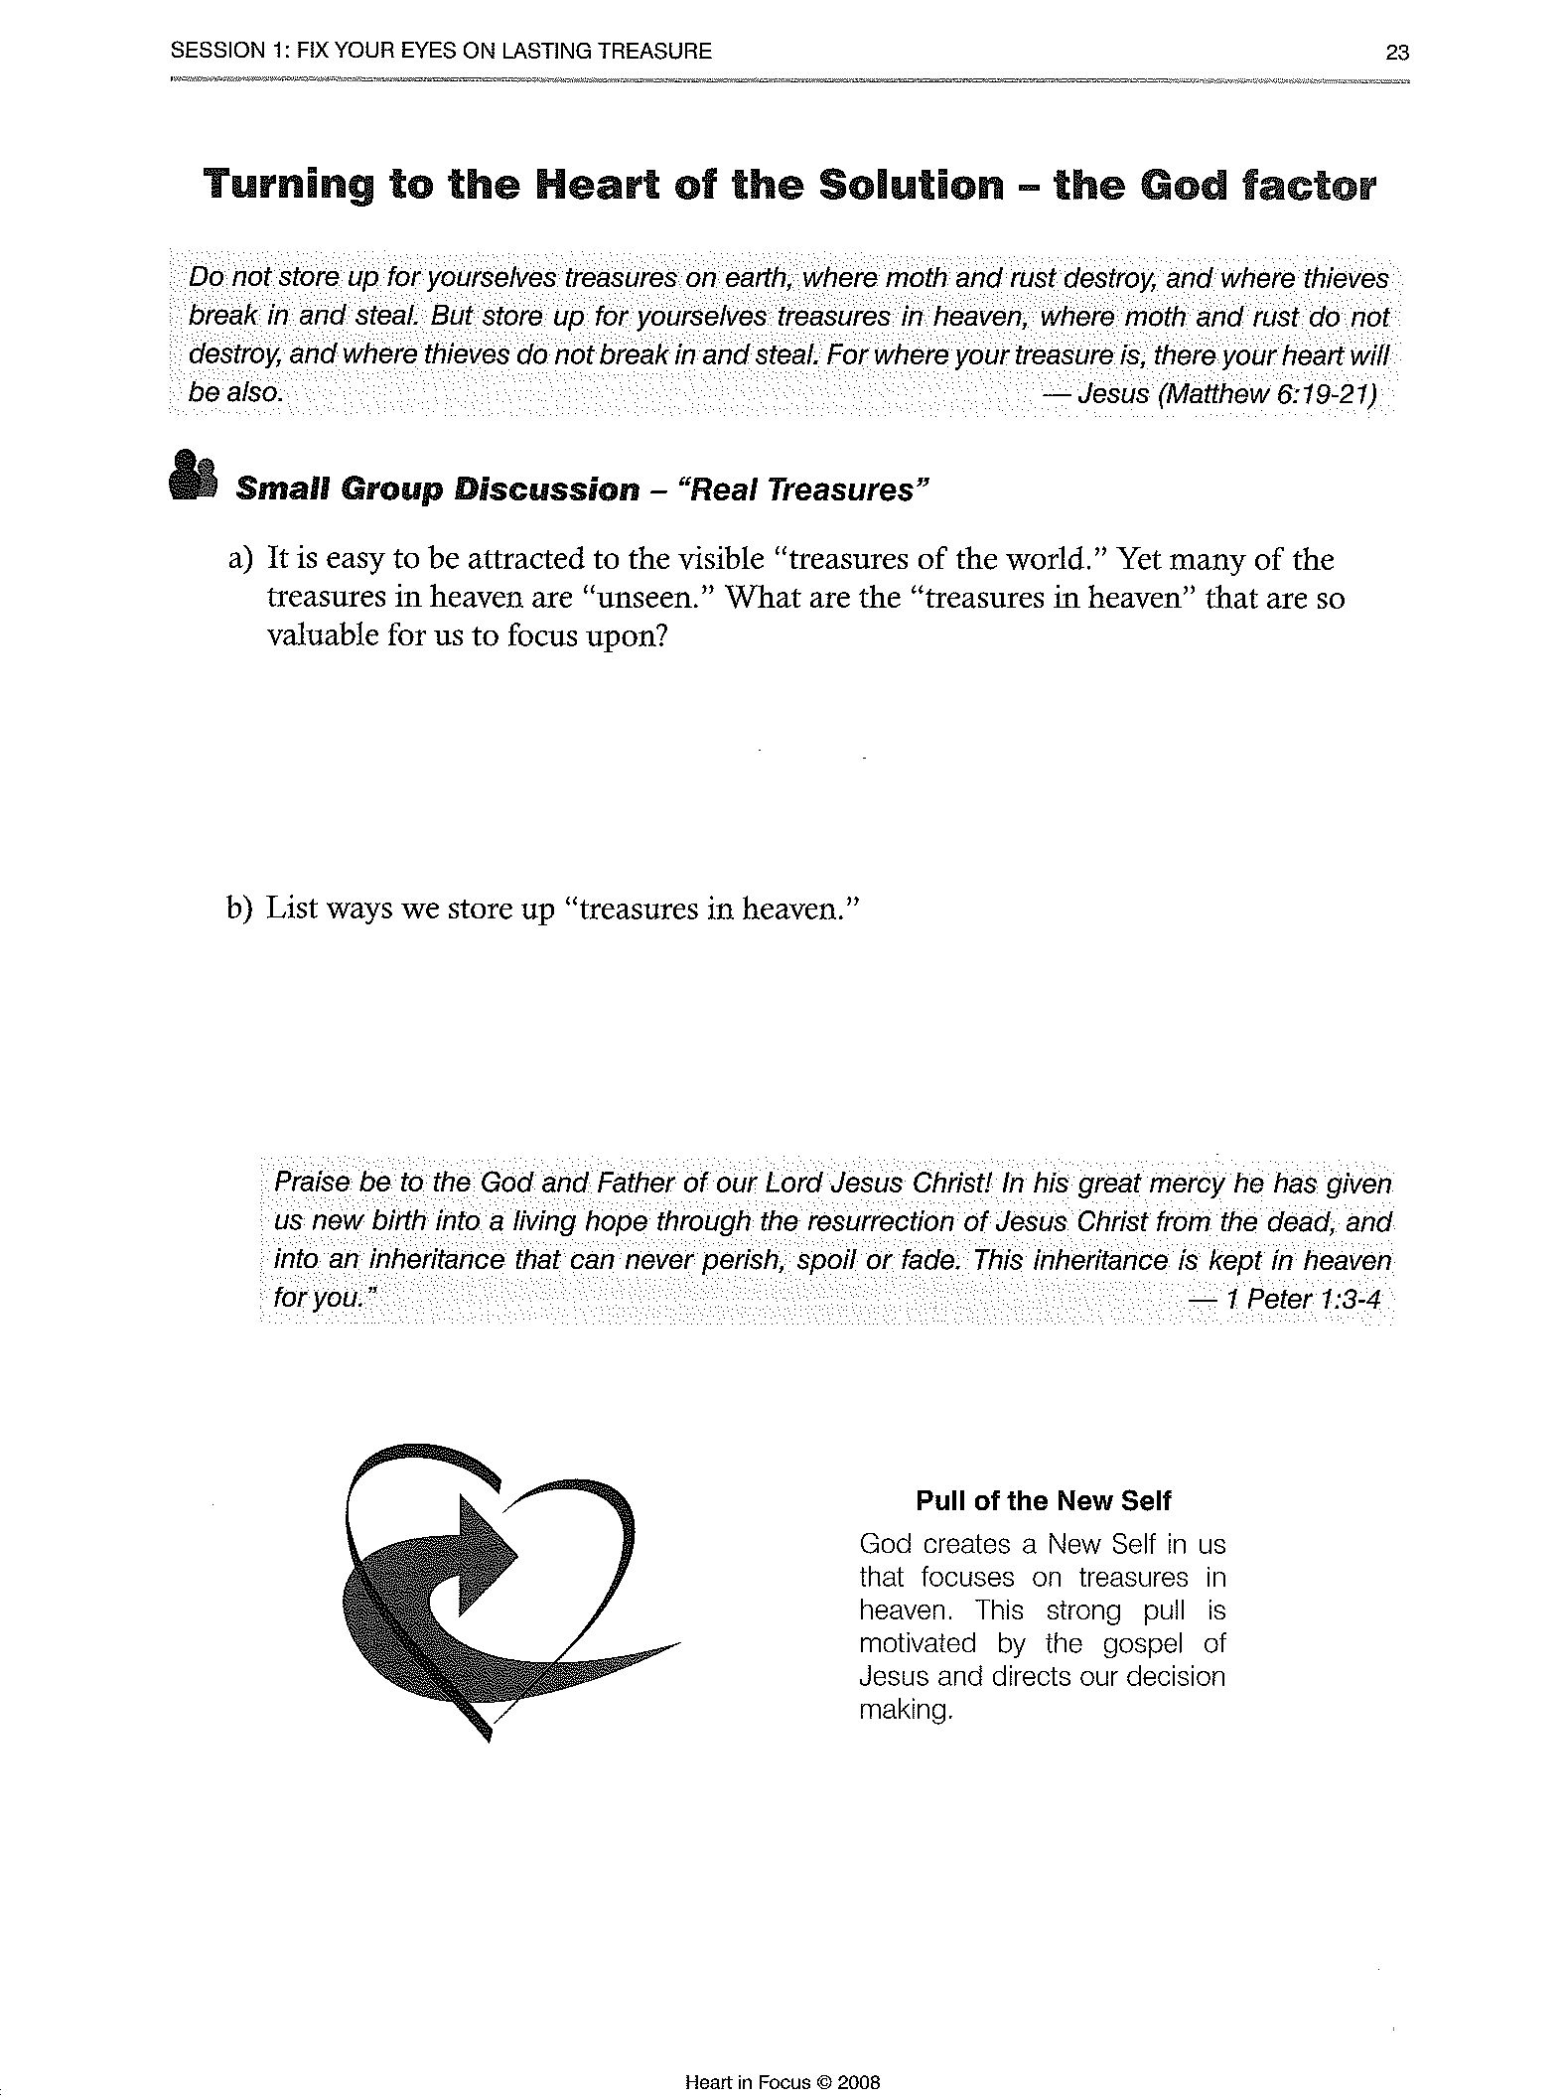
Finances and Debt

We used portions of Heart in Focus: A Faith Focused Financial Course by Jeffrey Davis and David Kehl to discuss 1) Earthly and heavenly treasures and 2) Debt, specifically credit cards.

We used pages 21-24, 55-58 including two video segments.
Heart in Focus materials are available at www. nph.net.

An Active and Growing Faith
Romans 10:17
Faith comes from hearing the message, and the message is heard through the word of Christ.
How will you stay in contact with God’s Word after high school so that your faith will continue to grow?

Matthew 26:26-28
While they were eating, Jesus took bread, gave thanks and broke it, and gave it to his disciples, saying, “Take and eat; this is my body.” ²⁷ Then he took the cup, gave thanks and offered it to them, saying, “Drink from it, all of you. ²⁸ This is my blood of the covenant, which is poured out for many for the forgiveness of sins.”
Why is it important to you to regularly receive the Lord’s Supper?
Hebrews 10:25
Let us not give up meeting together, as some are in the habit of doing, but let us encourage one another—and all the more as you see the Day approaching.
Our Lord wants us to gather together with other believers to encourage and to be encouraged. We most often do this on Sunday mornings at church. You, as a believer, want to continue to attend worship services. What obstacles might the devil, the world and your own sinful nature put in the way of you getting to church regularly?

One suggestion for going to church more often during college is to join something at church. Why would this help? What could you join?

There are many different Christian organizations on college campuses. Your friends at college may be involved in these groups. They may want you to go with them. Should you join your friends at these non Lutheran groups? Why or why not?

Acts 17:11
Now the Bereans were of more noble character than the Thessalonians, for they received the message with great eagerness and examined the Scriptures every day to see if what Paul said was true.
You are discussing religion with a group of friends at college. Someone challenges what you have been taught. You don’t know how to respond. Discuss your next steps.

What resources do you have for spiritual growth and for answering spiritual questions when you are away at college?

Numbers 6:24-26
The Lord bless you and keep you;
The Lord make his face shine upon you and be gracious to you;
The Lord turn his face toward you and give you peace.

